Kathryn Atherton

ABE 301

Project Deliverable 2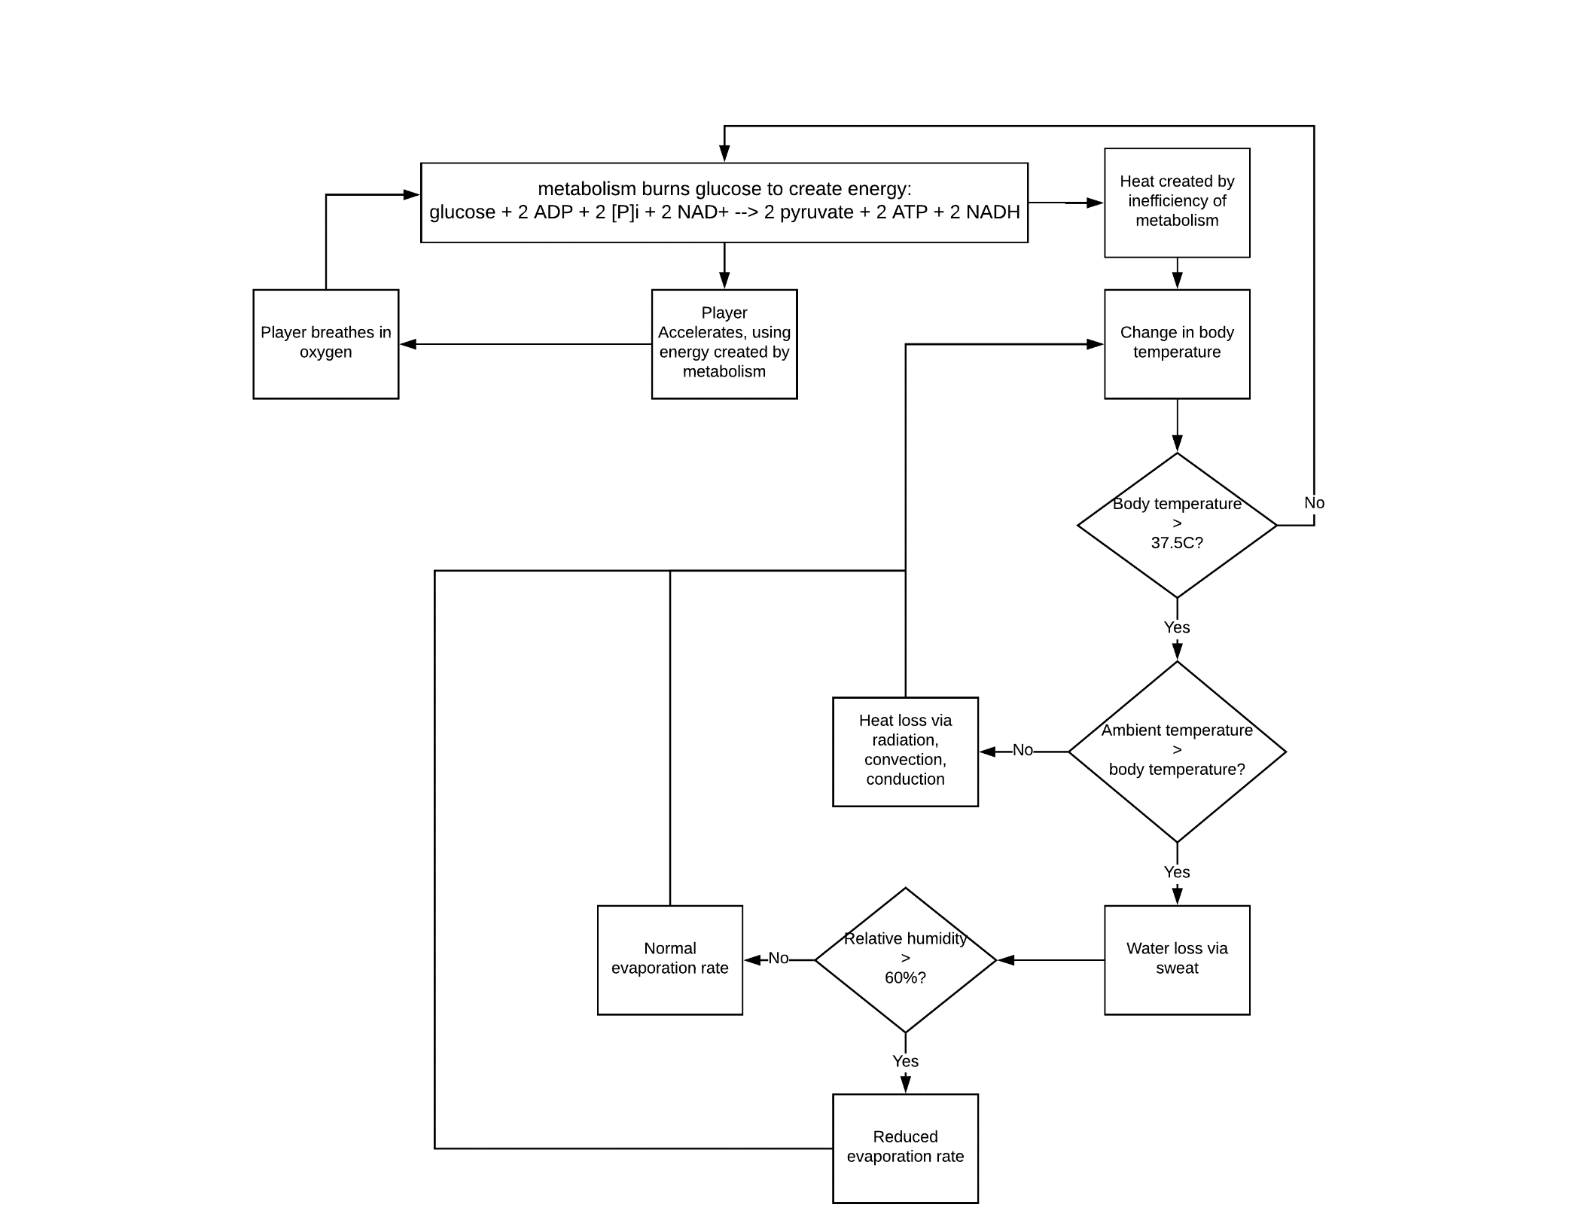

**Figure 1:** Process flow diagram. Shaded area represents the boundaries of the system.

List of equations:

* Mass balance of aerobic respiration reactants and products
  + C6H12O6 + 6 O2 🡪 6 CO2 + 6 H2O + heat
    - O2 limiter
    - H2O added to total body water content
* Energy balance of heat created by metabolism
  + Heat = mass * specific heat * Tfinal – Tinitial
    - Mass – input
    - Specific heat = 3500J/kg.K
    - Starting temperature = 37oC
* Heat loss via sweat
  + Psychrometric charts
    - Dry bulb temperature = ambient temperature = input
    - Relative humidity = input
    - Find where relative humidity curve = dry bulb temperature, follow diagonal line to wet bulb temperature
  + Heat lost = mass * specific heat * Tfinal – Tinitial
    - Tfinal = wet bulb temperature
    - Tinitial = Tfinal from metabolism energy balance
    - Specific heat = specific heat of water
    - Mass = surface area of player * 0.01 mm * density of water
  + Heat lost = mass * specific heat * Tfinal – Tinitial
    - Heat lost = heat calculated from above
    - Mass = player mass
    - Specific heat = 3500J/kg.K
    - Tinitial = Tfinal from metabolism energy balance
* Water mass balance – solving for how much water must be consumed between halves/after game
  + In – Out + Generation – Consumption = Accumulation
    - Accumulation = 0
    - Consumption = 0
    - Generation = water created in aerobic respiration
    - Out = mass lost via sweat
  + ((60% * mass – water out) / 60%*mass) * 100% = % body water loss
    - If > 5%, dehydration symptoms shown
* Oxygen mass balance
  + In – Out + Generation – Consumption = accumulation
    - Accumulation = 0
    - Consumption = oxygen used in aerobic respiration
    - Generation = 0
    - Out = 0
    - In α acceleration of player